Meeting MOH on proposed price cuts for the pharmaceutical industry, 9 Jan 2007
GENAS viewpoint

Cost by cause principle
GENAS stated on the meeting with MOH on 9 Jan 2007, that solidly price cut of which percentage ever cannot be accepted. All generic companies contribute to Health care savings since 2003 almost quarterly, there is no space any more.
The current significant rises in costs are caused by a few big blocks only (Me-too products, oncology, diabetes...) Opposite to Generics products in Slovakia (at the lowest European benchmark levels) those products achieve generous prices.

- Generic producers in Slovakia provide approx. 70% of treatments (boxes) for approx. 45% of costs only.

- The 2003-2006 Healthcare reforms effected a disproportional pressure on
Generic manufacturers why today the prices of Generic drugs in Slovakia rank among the lowest in Europe à the impact on potential further Generic price cuts must be considered very questionable

- It is our clear understanding that Generic drugs significantly create financial reserves within existing healthcare budgets, which can be allocated to real innovate drugs. Unfortunately the current Slovak reimbursement system provides extraordinary financial benefits to analogue drugs also, which cannot be seen as innovation at all. These so-called “me-too” drugs receive full reimbursement for multiple (!) prices of patent free generics, without any significant medical advantage.

- Life expectancy in the Slovak republic currently ranks significantly below the EU-average, but also below countries like Czech Republic. (CR: 72,1 male/78,5 female versus SR: 69,5 male/77,6 female) These alarming figures also correlate with the statistically lower consumption per capita of established standard drug regimes in Slovakia. An increased usage of generic drugs will contribute to help to fill this gap without strong impact on total drug expenditures. Nevertheless the aspired higher consumption of drugs per capita must be related in increased costs from payer side.
The graph below shows – representative for many blockbuster molecules-
the benefit of generic products for the Slovak healthcare. For the same costs like in 2000 almost 6 times more patients could be treated in 2006 with Amlodipine:

The same impact could have been observed in other molecules of high importance, both from medical as from cost point of view:

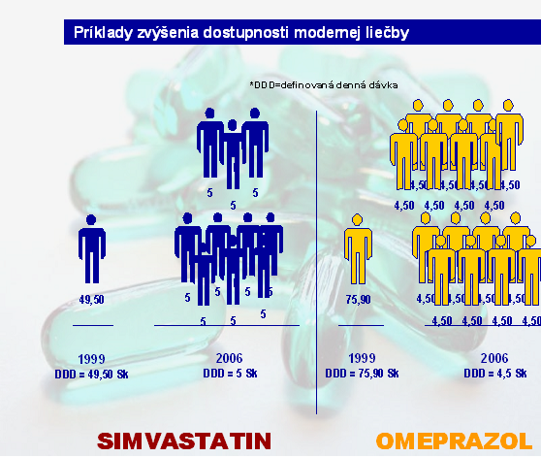
.

- GENAS stated on the meeting with MOH on 9 Jan 2007, that solidly price cut of which percentage ever cannot be accepted. All generic companies contribute to Health care savings since 2003 almost quarterly, there is no space any more.
The current significant rises in costs are caused by a few big blocks only (Me-too products, Oncology, Diabetes ...) Opposite to Generics in Slovakia (at the lowest European benchmark levels) those products achieve generous prices.
(according to the “cost by cause principle”)

- Further price cuts on Generic drugs might have to go hand in hand with subsequent reduction of Medical representatives in our companies. In other words, the Generic companies would have to reduce a workforce of some hundred qualified persons which help us and the public healthcare system to convince doctors about the rationales, why to use generic drugs. The created misbalance would lead to a significant higher share of voice originator companies and increased costs for the healthcare system.

- Extreme price erosion on „exchangeable“ molecules, whereas less contested
(even less established, older) molecules occupied comfortable niches

The 2003-2006 Healthcare reforms effected a disproportional pressure on
Generic manufacturers:

- Drug consumption in too many therapy groups below EU average
à Generics as a powerful tool to treat significantly more patients for similar
costs
- Plans on generic substitution have to be considered counterproductive
considering required Gx marketing activities à without adequate promotion by
Generic producers, prescribers will switch to patent-protected, more
expensive drugs (incl. „me too“ molecules)


Christian Wieser
Predseda GENAS

